TECHNICAL MEMORANDUM

To: Keven Kehlenbach and George Thornton
Baylor University

From: Mark Goode, P.E.
Luke Schmidt, P.E.
Kimley-Horn and Associates, Inc. Registered Firm F- 928

Date: August 2, 2017
Subject: Parking Supply and Demand Study for the Baylor University Louise Herrington School of Nursing – Academic Building, 333 N. Washington Avenue, Dallas, Texas 75246

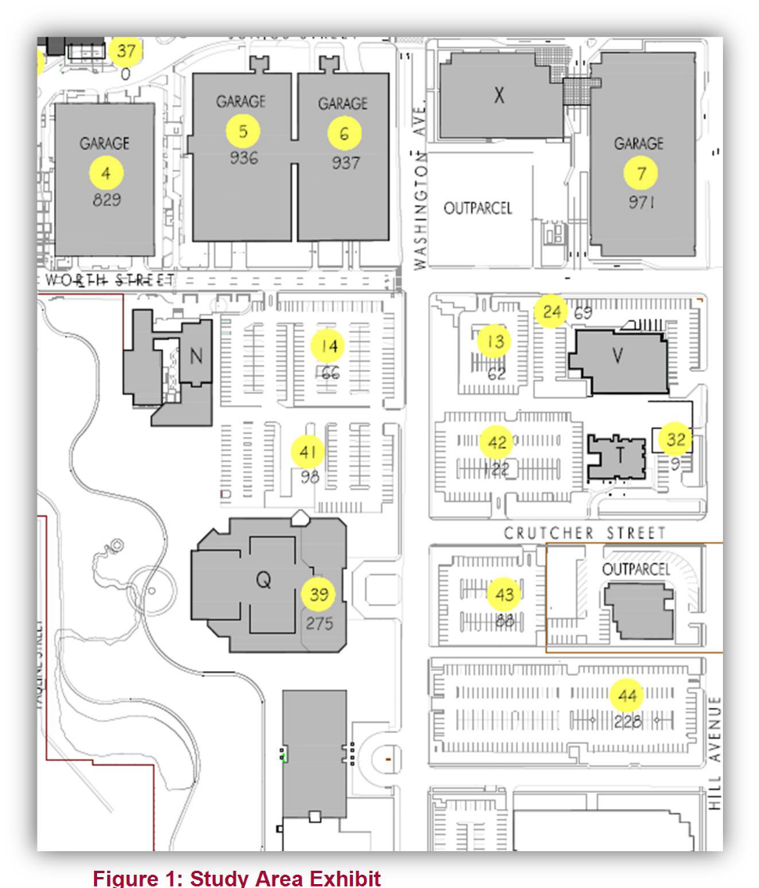
Baylor University and Baylor Scott & White (and its predecessor organizations) have shared a campus in east Dallas for nearly 100 years. The Baylor University Louise Herrington School of Nursing (LHSON) has acquired the Baptist General

Figure 1: Study Area Exhibit
Convention of Texas (BGCT) building which is part of the greater Baylor Scott
& White campus and is renovating the facility to accommodate academic and administrative functions. Baylor University LHSON academic activities are currently accommodated in buildings on Worth Street adjacent to Lot 14 (see Figure 1: Study Area Exhibit). Baylor University LHSON currently holds a lease agreement dating back to 1982 that contains the privilege of utilizing surface parking in Lot 14. Under the terms of the agreement, Baylor Scott & White provides additional permit parking in Garage 7. Lot 14 has 166 spaces and Garage 7 provides approximately 68
parking spaces in the north bay of Level
4 and 127 spaces on Level 5 to support
LHSON students and faculty. The

Lot 14
Garage 7

BGCT Building

existing BGCT building provides surface and below-grade structured parking for a total of 261 spaces. This study documents existing parking supply and demand counted during the spring semester of 2017 for the Baylor University Louise Herrington School of Nursing on the Baylor Scott & White campus. Figure 1: Study Area Exhibit shows the close proximity of the Baylor University Louise Herrington School of Nursing buildings and the integral nature of the campus environment. In the future faculty, staff and students will continue to utilize the parking in Lot 14, the renovated BGCT building and other campus facilities.

The BGCT and LHSON buildings benefit from the Baylor Scott & White Shuttle Bus Service. The shuttle service provides 2 routes on campus with generally overlapping routes that connect most buildings on campus to the surface and structured parking facilities and the DART station. The third route serves the Baylor Scott & White campus and extends to Baylor Scott & White offices in downtown Dallas. Each shuttle takes an average of 22 minutes to make a complete circuit, but do to the overlapping nature of the routes the headways are much shorter. The shuttle bus operation provides the benefit of making many parking opportunities available to different facilities and 4 DART stations as a viable and convenient alternative to using an automobile. The shuttle routes and information is provided in the Appendix. The BGCT facility is anticipated to be used by existing nursing school students, and is not anticipated to create a net addition to the student population/enrollment. The purpose of this study is to summarize the parking the parking supply and demand currently experienced by the Baylor University LHSON.

D AT A COLLECT ION
The initial step in this study was to collect parking occupancy data for Lot 14 and Garage 7 which currently serves Baylor University LHSON. In addition to the parking observations, a survey was distributed to the students in the program to assess their perspective of parking on campus as well as opportunities for other modes of travel.

Student Survey
The initial step in this study was to determine the perspectives of students in the program in regards to current commuting habits and desirability of supporting future alternative transportation options.
The web-based commuting survey was open from January 9th until January 20th, 2017. Approximately
23% of the students responded to the survey. The questions asked in the survey were as follows:

· | How d  (Pleas  o | o you typically travel to and from the Baylor University School of Nursing Campus?  e select all that apply) Drive Personal Car
 | o | Carpool/vanpool
 | o o o | On demand rideshare (e.g. Taxi, Uber, Lyft) Bicycle  Public Transit
 | o o | Walk  Other (Write-In)

· Where do you park when on campus?
o Parking permit for Baylor University parking lot 14
o Parking permit for Baylor Scott and White parking garage 7
o On street paid hourly parking near the campus o On street free hourly parking near the campus o Other parking facility
o Other (Write in)
· What days of the week do you typically park on campus? (Please select all that apply)
o Monday
o Tuesday
o Wednesday
o Thursday
o Friday
o Saturday
o Sunday
· If enhanced/secure bike parking was available, would you be more likely to ride a bike to the
Baylor School of Nursing Campus? (Please select all that apply)
o I would consider riding my bike to campus everyday
o I would consider riding my bike to campus once a week
o I would consider riding my bike to campus once a month
o I could consider using a combination of public transit and bike
o I still live too far to ride my bike to campus
o I do not feel comfortable riding my bike to campus
o Other (write in)
· How close do you live to campus?
o Within walking distance
o Within biking distance
o I must drive or ride to campus in a motorized vehicle
o Other (write in)
· What is your opinion of parking on campus?
o There are always parking spaces available when I park on campus
o There are sometimes parking spaces available when I park on campus
o There are never parking spaces available when I park on campus
o Other (Write in)
· Please share any other opinions, suggestions, or ideas to improve the transportation to and from the Baylor University School of Nursing Campus

The intent of these questions was to gauge the peak parking demand, how students arrive to campus now, how that could change if appropriate amenities were available, and any other points of view that could help plan the new BGCT facility.

From the survey, there were many findings, but the three main conclusions are as follows:

· Most students drive their personal car to school daily, or some combination of personal car and vanpool, transit, or walk. The number of students dedicated to other modes of travel is less prevalent.
· 86% of the students indicated that they either live too far to use a bike or do not feel comfortable using a bike to commute to school.
· The peak parking day is Monday, followed by Friday. This is consistent with the perspective of staff and the provided class schedules.
· Increased bike parking on campus could increase bicycle ridership as a form of commuting,
the survey showed some interest in alternative modes of travel. The survey results from this question are shown in Figure 2 on the next page. The survey shows that approximately
14% of students would consider riding their bike to school at some interval and 8%
would consider riding their bike every day.

The results from the remaining questions can be referenced in the Appendix.

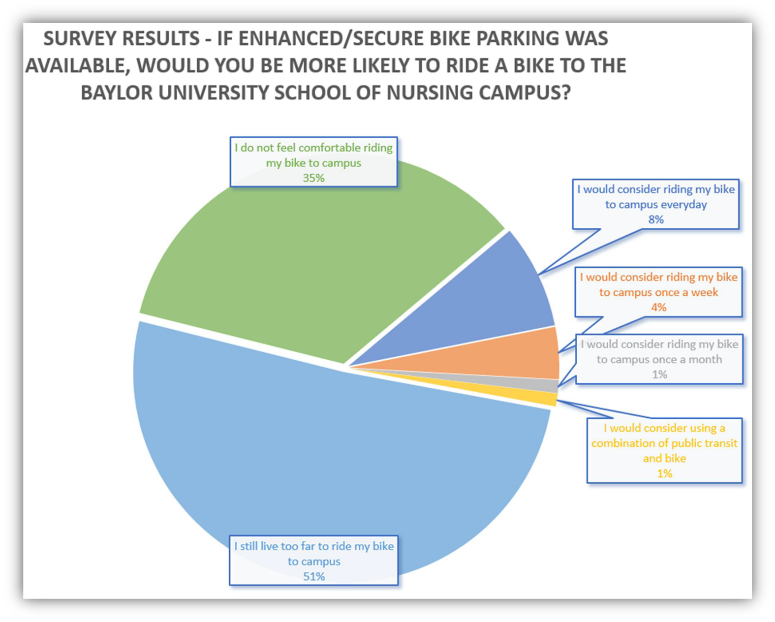
Figure 2: Bike Parking Usage

Parking Occupancy Data
Existing parking occupancy counts were collected on Monday January 23rd, 2017 while school was in session. Monday was identified as the peak parking day per the survey results, class schedules, and staff input. Data collection was performed hourly from 8:00 am to 5:00 pm. This time period was captured the peak parking load experienced at both Lot 14 and Garage 7.

Shown below in Figure 3 is a graph of Lot 14 occupancy by hour. The published parking supply in Lot
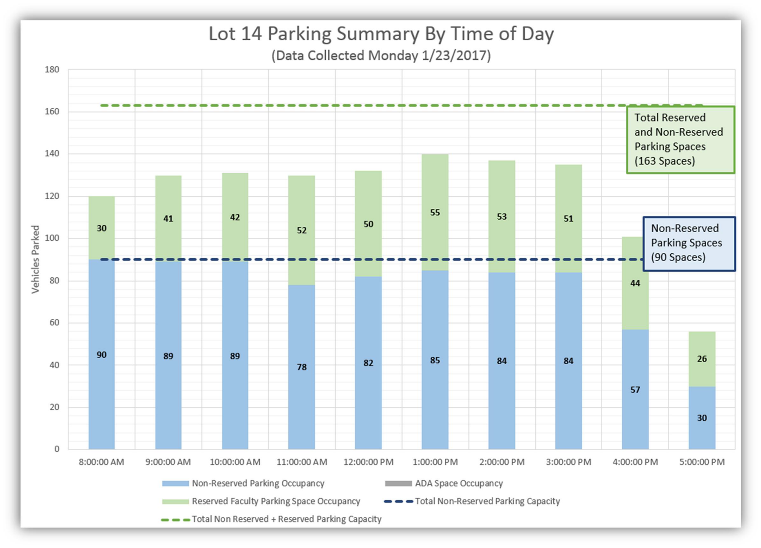
14 is 166 spaces. At the time of data collection, the parking lot was marked to park 163 vehicles, which is the total shown below. As shown, the non-reserved parking spaces are almost completely utilized throughout the day, but the reserved faculty spaces are only 75% utilized during the peak observation period. Overall the lot was approximately 86% utilized at the peak time of the day.

Figure 3: Lot 14 Parking Lot Occupancy

Shown below in Figure 4 is a graph of the Garage 7 occupancy by hour. Floors one and two are reserved for visitors, thus data was only collected for the remaining floors. As shown below, floor 3 parking spaces are almost completely utilized throughout the day, but floor 4 and floor 5 are about
75% utilized during the peak observation period. Worst case, this provides approximately 76 spaces
vacant in Garage 7. Throughout the day on average there is closer to 125 spaces available excluding the two peak parking hours. Garage 7 is not used solely for the Baylor University LHSON. Other
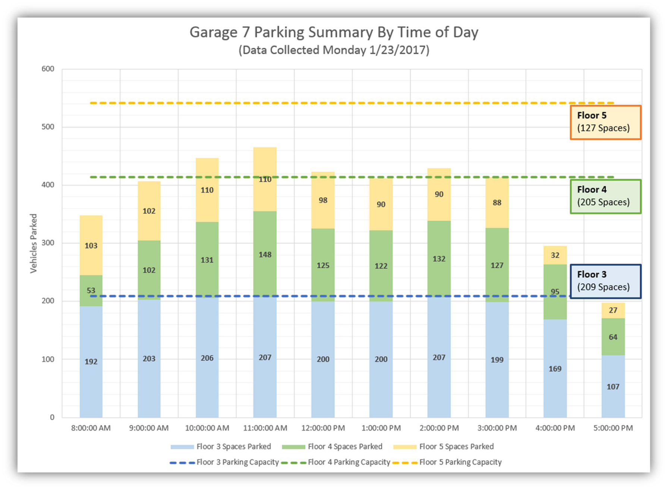
users and visitors can use the parking garage, as well. Baylor Scott & White parking and transportation services department issues an identity badge (with photo) to all Baylor University LHSON faculty, staff and students. The parking and transportation department sells parking permits

Figure 4: Garage 7 Parking Lot Occupancy

to all Baylor University LHSON faculty, staff and students for a nominal fee of $25-$30 per semester. Silver decal permits are issued to students that are classified as juniors and are directed to park only on the roof of Garage 7. Green decal permits are issued to faculty, graduate students and seniors and are permitted to park in Lot 14 or in Garage 7 on the roof.

The peak parking accumulation of faculty, staff and students documented on Monday, January 23,
2017 occurred at 11:00 am when approximately 289 vehicles were counted in Lot 14 and the designated areas in Garage 7. Approximately 285 vehicles were observed at 10:00 am and 271 vehicles observed at 1:00 pm.

The following table summarizes the peak period observations:

Table 1 - Peak Period Parking Observations

Observed Accumulation | Supply  Available | 10:00 AM | 11:00 AM | 1:00 PM
Lot 14 - Reserved | 73 | 42 | 52 | 55
Lot 14 - Non-reserved | 90 | 89 | 78 | 85
Garage 7 - Floor 4 | 68 | 44 | 49 | 41
Garage 7 - Floor 5 | 127 | 110 | 110 | 90
Total Peak Accumulation | 358 | 285 | 289 | 271

Baylor Scott & White and Baylor University LHSON - One Campus
The BGCT facility is anticipated to be used by existing nursing school faculty, staff and students that are already on the Baylor Scott & White campus occupying existing Baylor University LHSON facilities adjacent to Lot 14. The BGCT building adds 261 spaces to the overall campus parking
supply available to serve faculty, students and staff. The BGCT renovation is not anticipated to create a net addition to the existing student population/enrollment. Possible future enrollment increases are nominal as shown in the enrollment table in the Appendix. The existing parking occupancy counts showed that Lot 14 is approximately 86% utilized during the peak hour on the peak day. Additionally, the Baylor Scott & White campus shuttle provides direct access to four DART light rail stations as shown in Figure 5 (Baylor University Medical Center Station, Deep Ellum Station, St. Paul Station,
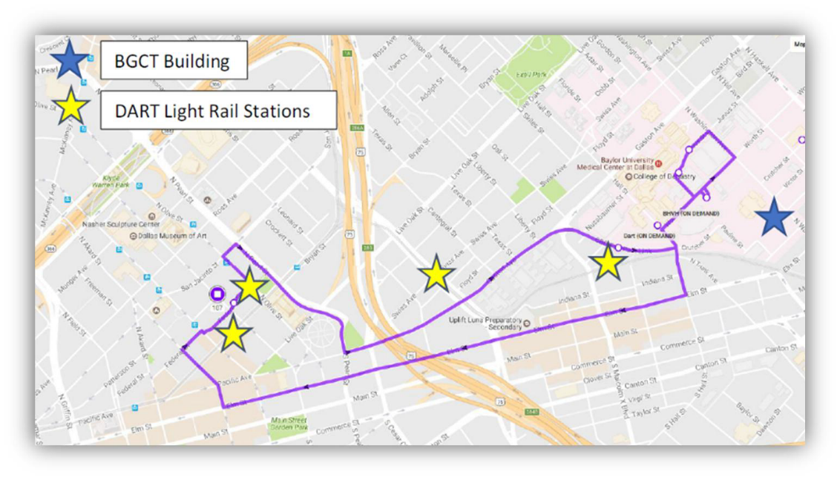
and Pearl/Arts District Station).

Figure 5: DART Park and Ride Stations near Campus

CONCLUS IO NS AND R ECO MMEND AT ION S
This study documents existing parking supply and demand counted during the spring semester of
2017 for the Baylor University Louise Herrington School of Nursing on the Baylor Scott & White campus. Figure 1: Study Area Exhibit shows the close proximity of the Baylor University Louise Herrington School of Nursing buildings and the integral nature of the campus environment. In the future, faculty, staff and students will continue to utilize the parking in Lot 14, the renovated BGCT building and other campus facilities.

Lot 14 has 163 observed spaces and Garage 7 provides approximately 68 parking spaces in the north bay of Level 4 and 127 spaces on Level 5 to support LHSON students and faculty. The existing BGCT building provides surface and below-grade structured parking for a total of 261 spaces. The parking occupancy counts showed that the existing Lot 14 was 86% utilized during the peak hour of the day. Similarly Garage 7 averages between 75 and 125 parking spaces available on Levels 4 and
5.

Table 1 shows that 358 parking spaces are currently available for the Baylor University Louise Herrington School of Nursing on the Baylor Scott & White campus. In addition, Table 1 shows that 289 parking spaces are needed for nursing school students, faculty, and staff at the peak time. Expanding the school campus to 333 N. Washington Avenue increases the amount of available parking by 261 space. Therefore, there will be 163 spaces on Lot 14 and 261 spaces at
333 N. Washington Avenue for a total of 424 available parking spaces for the school and only
289 spaces are needed based on this study.

Appendix

Attachment A:

Student Survey Results

Attachment B:

Current and Future Enrollment

Attachment C:

Baylor Shuttle Service Information

Attachment A: Student Survey Results

Page 1: Transportation and Parking Survey - Only 7 Questions

Baylor University is always trying to provide more convenient methods of transportation for students and staff accessing the facility. These questions are asked to better understand how people commute to the campus and evaluate additional needs for all modes of travel.

This survey will close on Friday January 20th, 2017.

Thank you for taking a few moments to answer the survey questions.

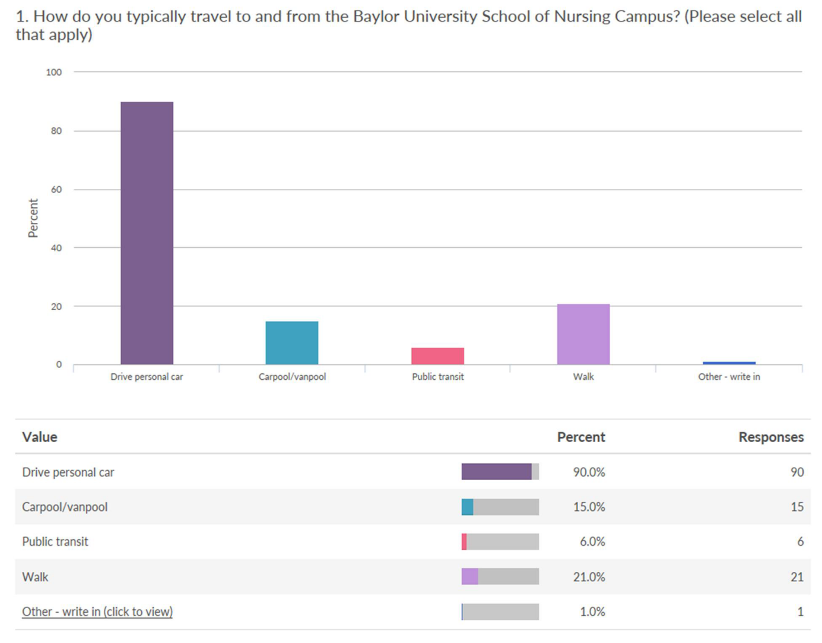

2. Where do you park when on campus?

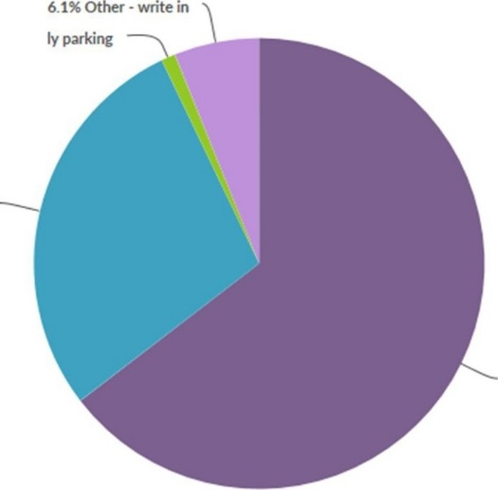
1.0% On street paid hourly parking
near the campus

28.3% Parking permit for Baylor
Scott and White parking gafdlge 7

64.6% Parking permit for Baylor
University parking lot 14

Value

Parking permit for Baylor University parking lot 14

Parking permit for Baylor Scott and White parking garage 7

On street paid hourly parking near the campus

Other·write in (click to view)

Other - write in

I park at the dart station near my home. I take the Dart train so Iwalk
lAS test

Lot 14 if available.Free parking on street if available.Or garage if nothing is available. Park in lot 14 after hours
usually park in nursing schoollot 7 after Spm & on weekends

Total
Percent

64.6%
•
-

28.3%

1.0%

6.1%
Responses

64

28

1

6

Total:99

Count

1

1

1

1

1

1

6

3. What days of the week do you typically park on campus? (Please select all that apply)

100

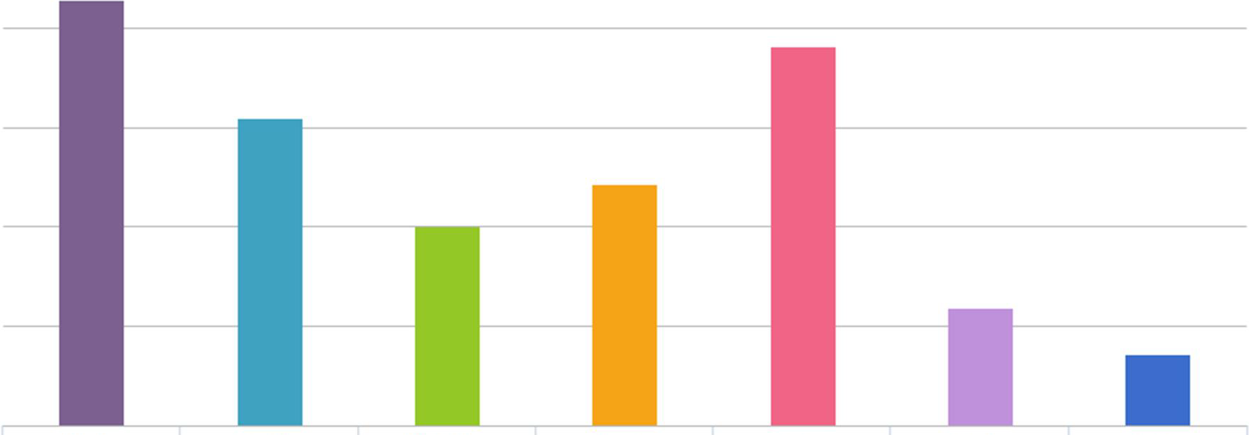
80

60
c:
"'
c"..'
40

20

0
Monday

Tuesday Wednesday Thursday

Friday Sarurday Sunday

•-------
Value | Percent | Responses
Monday | 85.6% | 83
Tuesday | 61.9% | 60
Wednesday | 40.2% | 39
Thursday | 48.5% | 47
Friday | 76.3% | 74
Saturday | 23.7% | 23
Sunday |  | 14

14.4%

4. If enhanced/secure bike parking was available, would you be more likely to ride a bike to the Baylor
University School of Nursing Campus? (Please select all that apply)

60

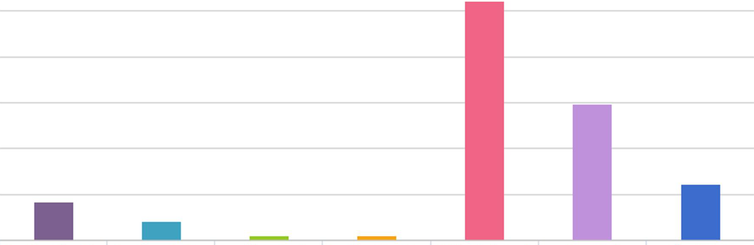
so

40

c
Q)
30
Q)
a.

20

10

0
I would consider riding my bike to campus everyday

I would consider riding I would consider riding my bike to campus once my bike to campus once a week a month

I would consider using a combination of public trcmsit .and bike

I still live too far to ride
my bike to campus

I do not feel comfortable riding my bike to campus

Other - Write In

Value

I would consider riding my bike to campus everyday

I would consider riding my bike to campus once a week

I would consider riding my bike to campus once a month

I would consider using a combination of public transit and bike

I still live too far to ride my bike to campus

I do not feel comfortable riding my bike to campus

Other - Write In (click to view)
Percent Responses

8.2% 8

4.1% 4
-

1.0% 1

1.0% 1

52.0% 51

29.6% 29

12.2% 12

Other- Write In  I don't have a bike | Count  2
Don't bike.Just walk | 1
Don't have a bike | 1
I do not own a bike,therefore would not ride one | 1
I don't have a bike | 1
I don't own a bike | 1
I don't own a bike | 1
I walk | 1
lAS test | 1
i don't ride a bike | 1
no I would rather walk | 1
Total | 12

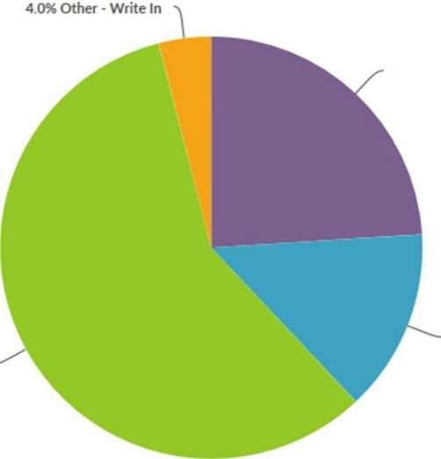
24.0% Within walking distance

58.0% I must drive or ride to
campus in a motorized vehicle
14.0% Within biking distance

Value

Within walking distance

Within biking distance

I must drive or ride to campus in a motorized vehicle

Other - Write In (click to view)
Percent

I 24.0%

14.0%
-

58.0%

4.0%
Responses

24

14

58

4

Total: 100

other- Write In  25-30mins | Count  1
45miles | 1
5 minute drive,20 minute walk | 1
LAs test | 1
Total | 4

7.2% Other·Write In

7.2% There are never parking spaces available when I park on campus

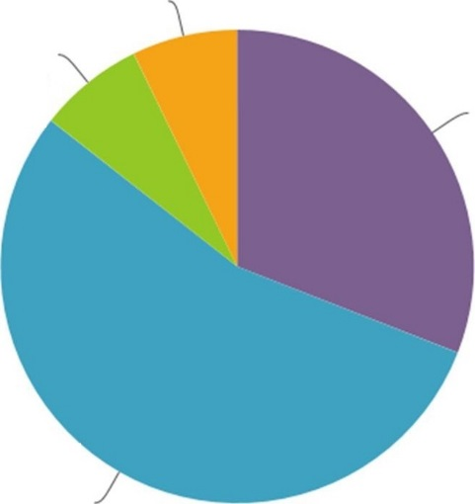
30.9% There are always parking spaces available when I park on campus

54.6% There are sometimes
parking spaces available when I

Value

There are always parking spaces available when I park on campus There are sometimes parking spaces available when I park on campus There are never parking spaces available when I park on campus Other - Write In (click to view)

Other - Write In

Ihave no clue, I have never parked on campus during the semester

I wish there was a closer place for juniors to park in the event that there is severe weather

Las test

Our parking options are too far so I usually pay for parking in order to be closer

There are always parking spots in garage 7,but not always next to campus in lot 14

There definitely needs to be more parking

Total
Percent

30.9%

54.6%
-

7.2%

7.2%
Responses

30

53

7

7

Total: 97

Count

1

1

1

1

1

1

6

7. Please share any other opinions, suggestions,or ideas to improve the transpor tation to and f rom the Baylor
University School of Nursing Campus.

minute faculty
SP.otsschool c ass
closer l otga ragesafe .
park 14! bikenurstng
p
a access
stuca e ntsteel
spot
accommodate

1 Sam-10:50 is the worst time.Along with 1:30pm

1 Actually offer transportation for those students that live far

1 Because I live so far (30mi) from campus,I leave home early to beat the traff ic so parking in lot 14 not a problem at 6:30am.

1 Get us a closer parking lot

1 Having another lot near the school for students to park where we feel safe to walk to our cars at night. Walking to the parking garage at night can be scary esp. when you are alone.

1 I don't mind parking in the parking garage.However, it adds 5-10 minutes on to my commute JUST to get into the garage and drive to the top level, depending on if the cars ahead of me are going an appropriate speed or extremely slow. I live at the Marquis on Gaston (a 3-5 minute drive away) and I still have to leave 30 minutes before class,when driving, for this reason.

1 I feel like the system works well!

1 I feel the parking has been extremely limited. I drive an hour in from Melissa to class and then make a 10 minute walk from the garage because the lot is always full.

1 I really liked being able to park in the parking garage in Presley,when it was available. it made it more convenient to get to and from class.

1 I think it would be a good idea to have more safe bike stands at the school and more parking in lot 14

1 I think that it's of advantage that Seniors get to park in lot 14 next to school;however since weare not allowed to park in faculty, many of us have to end up parking farther away or on the street since the already limited spots fill up quickly. I think that the Baylor nursing school would benefit its students if it had more parking spots closer to not only make it easier essentially, but to also be safer for students.

1 If there could be a way to see that parking is full so I wouldn't try go into the parking lot and trying to find a spot.

1 Jl and J2 students should have a 15 minute parking spot in Lot 14 for when we have to print something or grab something quickly from the nursing school.

1 Las test

1 More parking in the lot for seniors

1 More parking would be beneficial

1 Need more parking close to the nursing school. Consider taking away some of the faculty spots that are never used

1 None

Attachment B:
Current and Future Enrollment

kimley-horn.com 13455 Noel Road, Two Galleria Office Tower, Suite 700, Dallas, TX 75240 972 770 1300

Current and Future Enrollment
Semester | Fall 2016 | Spring 2017 | Projected Fall 2017 | Projected Spring 2018 | Projected Fall 2018 | Projected Spring 2019
Level 1  (Junior first semester) | 133 | 67 | 138 | 95 | 130 | 95
Level 2  (Junior second semester) | 72 | 133 | 68 | 131 | 90 | 120
Level 3  (Senior first semester) | 108 | 66 | 119 | 65 | 120 | 85
Level 4  (Senior second semester) | 55 | 108 | 68 | 119 | 63 | 120
FastBacc | 50 | 47 | 64 | 60 | 65 | 61
Total Undergraduate | 418 | 421 | 457 | 470 | 468 | 481

Semester | Fall 2016 | Spring 2017 | Projected Fall 2017 | Projected Spring 2018 | Projected Fall 2018 | Projected Spring 2019
MSN-FNP | 2 | 3 | 1 | 1
DNP-NP | 29 | 24 | 27 | 27
DNP-NM | 15 | 14 | 12 | 12
MSN-Leadership | 12 | 10 | 10 for sure possible  12 | 6 for sure possible 8
Total Graduate | 58 | 51 | 50 | 46

Total Dallas Campus 476 472 507 516 468 481

Source: Baylor Scott & White and Baylor University LHSON

Attachment C:
Baylor Shuttle Service Information

kimley-horn.com 13455 Noel Road, Two Galleria Office Tower, Suite 700, Dallas, TX 75240 972 770 1300

DALLAS CAMPUS
SHUTTLE SCHEDULE AND STOPS
EFFECTIVE: September 20, 2016

NORTH ROUTE
SOUTH ROUTE

Weekdays 5:30 a.m. - 9 p.m. Round Trip Route is 22 minute
Landry Center: 411 N. Washington circle drive [Access to Garage 39, Lots
14, 40, 41, 42, 43] Transfer point: SOUTH route.
Lots 44, 45: Hill St. entrance to Lot 45. Transfer point: SOUTH route.

4005 Crutcher: north entrance [Access to Lots 49, 55, 59, Baylor Credit Union, Baylor Parking Services] Transfer point: SOUTH route.
Baylor Medical Pavilion, Garage 7: valet station at 3900 Junius St. [Access to
Criswell College] Transfer point: SOUTH route.
Baylor Medical Plaza: south side of Barnett Tower on Junius St. [Access to Barnett, Wadley, Hoblitzelle, Jonsson, Truett] Transfer point: BRYAN TOWER / DOWNTOWN, and SOUTH routes.
Roberts Hospital: circle drive on Junius St. [Access to Barnett, Wadley, Hoblitzelle, Jonsson, Truett] Transfer point: BRYAN TOWER / DOWNTOWN, and SOUTH routes.
DART Rail Station at Baylor: on CBD Link–Fair Park Blvd. Transfer point: SOUTH
route.
Sammons Cancer Center: 3409 Worth St. Transfer point: BRYAN TOWER / DOWNTOWN, and SOUTH routes.
ON DEMAND:
Hamilton Heart and Vascular Hospital: valet station / North circle drive 621
Hall St. [Access to Garage 10, Lot 19]
Baylor Research (BIIR): 3434 Live Oak front entrance [Access to Baylor
Research Institute, Baylor Institute for Immunology Research, Lot 60].
Roberts, Physician Referral Center: Hall St. entrance to Physician Referral
Center and Roberts Hospital. Transfer point: SOUTH route.
4004 Worth St.: northeast corner of Worth St. at Hill St. [Access to Lots 24,
57, 58] Transfer point: SOUTH route.

BRYAN TOWER/DOWNTOWN ROUTE

Weekdays 5:30 a.m. - 9 p.m. Round Trip is 22 minutes
Baylor Medical Plaza: south side of Barnett Tower on Junius St. [Access to Barnett, Wadley, Hoblitzelle, Jonsson, Truett] Transfer point: BRYAN TOWER/ DOWNTOWN and NORTH routes.
Roberts Hospital: Roberts Hospital circle drive on Junius St. [Access to Barnett, Wadley, Hoblitzelle, Jonsson, Truett] Transfer point: BRYAN TOWER/ DOWNTOWN and NORTH routes.
Twice Blessed House II: (Marquis Apts.) east side of Malcolm X Blvd. and
CBD Link-Fair Park Blvd.
DART Rail Station at Baylor: on CBD Link-Fair Park Blvd. Transfer point:
NORTH route.
Sammons Cancer Center: 3409 Worth St. (school entrance)Transfer point:
BRYAN TOWER/DOWNTOWN and NORTH routes.
Baylor School of Nursing: 3700 Worth St. [Access to Garages 4, 5, 6, Lot 14]
Landry Center: 411 N. Washington St. circle drive [Access to Garage 39, Lots
14, 40, 41, 42, 43] Transfer point: NORTH route.
Lot 47: northeast corner of Race St. at Washington Ave. [Access to Lot 47]
Main Street Annex: 3801 Main St. north entrance [Access to Lot 21]

Lots 44, 45: Hill St. entrance to Lot 45 Transfer point: NORTH route.
4005 Crutcher: north entrance [Access to Lots 49, 55, 59, Baylor Credit Union, Baylor Parking Services] Transfer point: NORTH route.
Baylor Medical Pavilion, Garage 7: Valet station at 3900 Junius St. [Access to Criswell College] Transfer point: NORTH route.
ON DEMAND
Main Street Annex: 3801 Main St. North entrance [Access to Lot 21]
Roberts, Physician Referral Center: after 5 p.m. Hall St. entrance to
Physician Referral Center and Roberts Hospital. Transfer point: NORTH route.
4004 Worth St.: northeast corner of Worth St. at Hill St. [Access to Lots 24,
57, 58] Transfer point: NORTH route.

Weekdays 5:30 a.m. - 7 p.m. ; After 7 p.m. ON DEMAND Departs Bryan Tower :15 and :45 past the hour
Departs Baylor Medical Plaza :00 and :30 past the hour
Baylor Medical Plaza: south side of Barnett Tower on Junius St. [Access to Barnett, Wadley, Hoblitzelle, Jonsson, Truett] Transfer point: NORTH and SOUTH routes.
Roberts Hospital: Roberts Hospital circle drive on Junius St. [Access to Barnett, Wadley, Hoblitzelle, Jonsson, Truett] Transfer point: NORTH and SOUTH routes.
Bryan Tower/Downtown: 2001 Bryan St., Federal St. entrance [Access to Downtown Dallas DART Rail and Bus Stations] DART Rail riders: Pearl and St. Paul stations are nearest to Bryan Tower and the Baylor shuttle stop.
Sammons Cancer Center: 3409 Worth St. Transfer point: NORTH and SOUTH
routes.
ON DEMAND
Hamilton Heart and Vascular Hospital: 621 Hall St. [Access to Garage 10, Lot 19]
DART Rail Station at Baylor: on CBD Link–Fair Park Blvd. Transfer point:
SOUTH route.

ASSISTANCE:
Shuttle / Parking Inquiries: 214.820.7275
Shuttle After Hours - ON DEMAND:
214.676.3314
Security Escorts: 214.820.4444
Emergency Assistance: 214.820.4444
Online: www.BaylorBus.com

©2016 Baylor Scott & White Health BUMCD_1183_ 2016 SOM

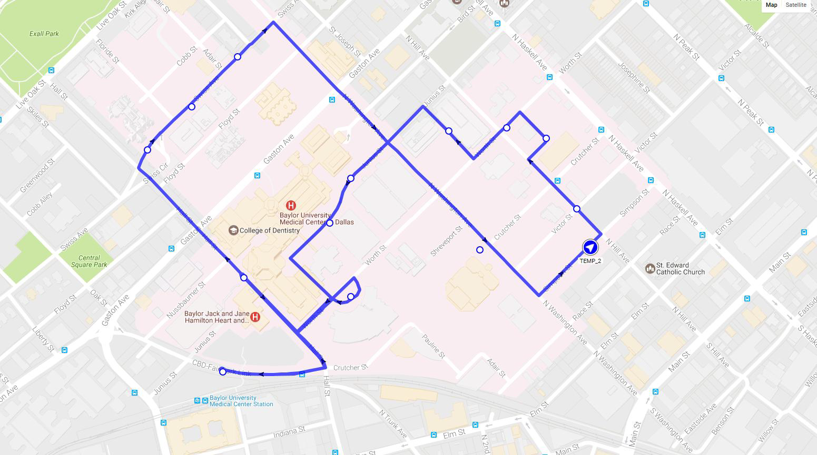
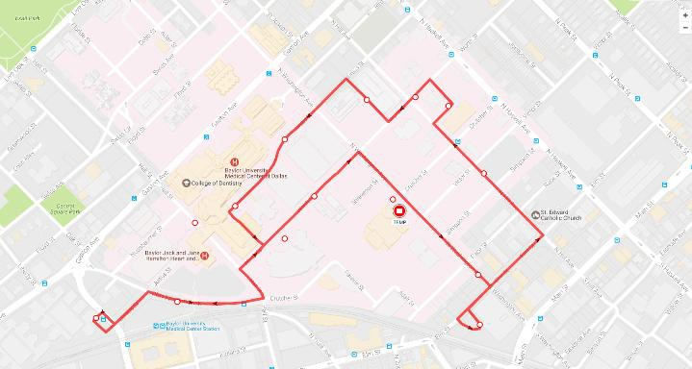

BGCT Building

DART Light Rail Stations

South Route (source http://www.baylorbus.com/):

BGCT Building

DART Light Rail Stations

,_o•

.... ..
..
"'
..
Map S.tellite

/1!
G) <!)

" "
ill>

corn rceS\Ift
z
canton S\

clo er Sl \ can\on $\

"

lJ,ainS\
t>,J,rgl\5\
1iai\orst '?'#-9
"

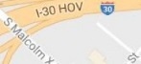
1-30HOV m

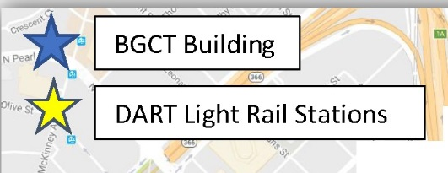
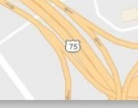
<!)
.<
"
cornrnelce S\

